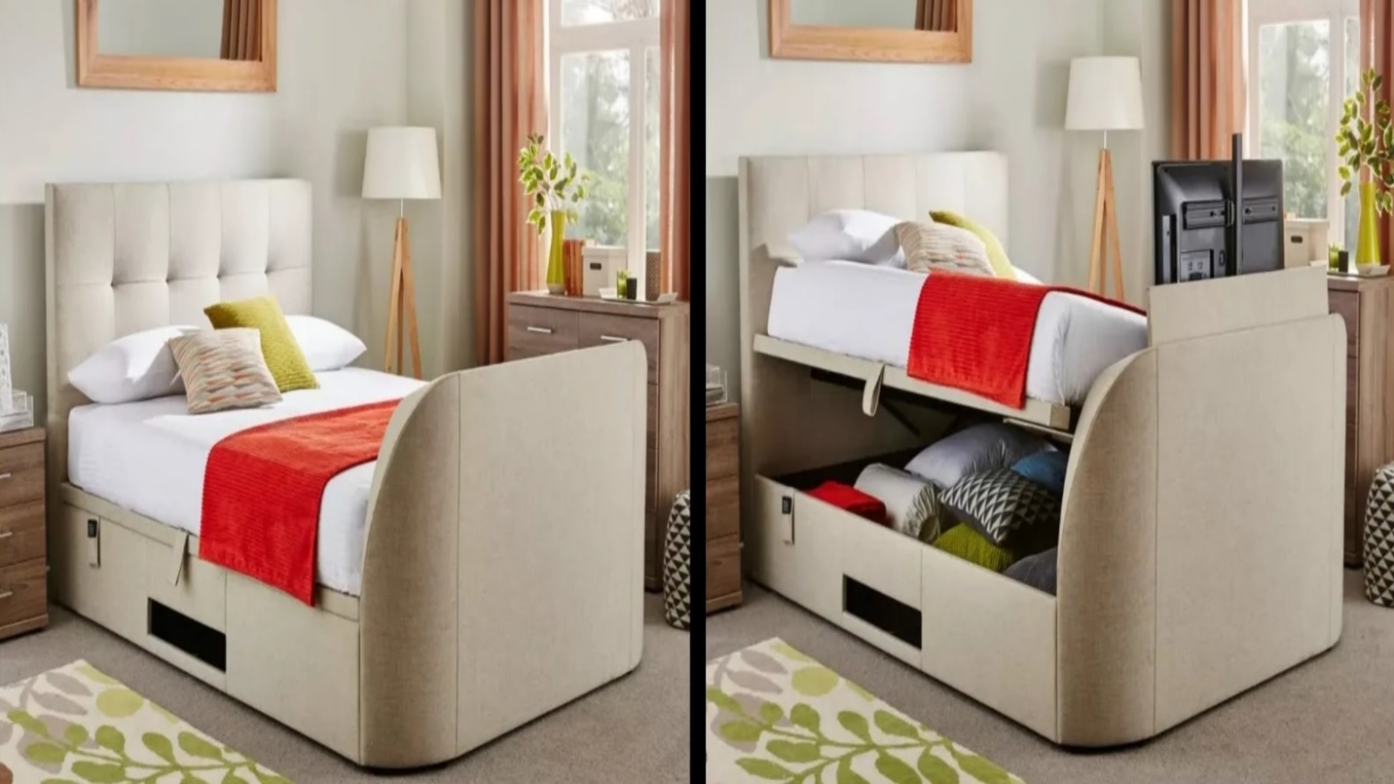

|  |  |
| --- | --- |
| **Title** | Bed With Side-Lid |
| **Size** | 1.9 m long ; 1.9 m wide; 1.9 high |
| **Weight** | 135 kg |
| **Price** | $1,050.00 |